# Quinte Financial Technologies | FinTech Solutions

**Assignment on**

**DEBIT AND PREPAID CARDS**

**Under Supervision of:**

**Mr. Mohammad Mozammil**

**Submitted On:**

**1th July, 2024**

**Submitted By:**

**Archita Gupta**

Table of Contents

Debit Card 3

Prepaid Card 9

# Debit Card

A debit card is a payment card that deducts money directly from your checking account. Also called “check cards” or "bank cards," debit cards can be used to buy goods or services or to get cash from an ATM. Debit cards can help you reduce the need to carry cash, although using these cards can sometimes entail fees.

Unlike credit cards, debit cards use funds you already have, not borrowed money.

**Key Features:**

1. **Direct Link to Bank Account**: Funds are directly withdrawn from your checking or savings account.
2. **Immediate Payment**: Transactions are processed in real-time or near real-time.
3. **PIN Security**: Requires a Personal Identification Number for transactions, enhancing security.
4. **EMV Chip**: Many debit cards are equipped with EMV chips for added security against fraud.
5. **Online Banking Integration**: Often integrated with online banking services for easy account management.
6. **Contactless Payments**: Many cards support NFC (Near Field Communication) for tap-and-go payments.
7. **ATM Access**: Can be used to withdraw cash from ATMs.
8. **Daily Spending Limits**: Some cards have daily transaction limits for added security.
9. **Rewards Programs**: Some debit cards offer rewards or cashback on purchases.
10. **Fraud Protection**: Often include fraud detection and reporting services.

**Types:**

1. **Standard Debit Cards**: Linked to a checking or savings account, used for everyday transactions.
2. **Prepaid Debit Cards**: Loaded with a specific amount of money and not linked to a bank account.
3. **Electronic Benefits Transfer (EBT) Cards**: Used to distribute government benefits.
4. **Payroll Debit Cards**: Used by employers to pay employees, typically for those without bank accounts.
5. **Student Debit Cards**: Targeted at students, often with educational benefits and lower fees.
6. **Business Debit Cards**: Linked to a business account, used for business expenses and transactions.

**Types of Debit Card Systems**

Debit card transactions can be processed in three main ways:

1. **EFTPOS (Electronic Funds Transfer at Point of Sale) / Online Debit / PIN Debit**:
   * **Authorization**: Requires electronic authorization for every transaction.
   * **Immediate Deduction**: Debits are reflected in the user’s account immediately.
   * **PIN Authentication**: Often secured with a Personal Identification Number (PIN) for each transaction.
   * **Usage**: Used with electronic authorization devices and PIN pads at the point of sale.
   * **Advantages**: More secure due to real-time processing and PIN authentication; minimizes risk of fraud.
2. **Offline Debit / Signature Debit**:
   * **Authorization**: Typically, no immediate electronic authorization.
   * **Delayed Deduction**: Funds are deducted from the account after a delay.
   * **Signature Verification**: Authentication is done through the cardholder’s signature.
   * **Usage**: Accepted where credit cards are accepted, since they often carry credit card logos (e.g., Visa, Mastercard).
   * **Advantages**: Can be used in locations without electronic authorization devices.
3. **Electronic Purse Card System**:
   * **Stored Value**: Value is stored on the card chip itself, not in an external account.
   * **No Network Required**: Machines accepting the card do not need network connectivity.
   * **Usage**: Widely used in Europe for small transactions; includes systems like Germany’s Geldkarte and France’s Moneo.
   * **Advantages**: Convenient for small transactions; quick and easy to use without the need for authorization.

**Debit Card Fees:**

Generally, debit cards do not have annual membership fees or cash-advance charges, but there are other potential fees to consider.

* ATM transaction fee: If you withdraw cash from an ATM that's not affiliated with the bank that issued your debit card, you may be charged an ATM transaction fee. These fees are also called "out-of-network" fees.
* Insufficient funds fee: If you use the card to spend more than you have in your account, you can face an insufficient funds charge. These fees are also called non-sufficient funds (NSF) fees.
* Overdraft fee: If you've registered for overdraft protection and spend more than your limit, your purchase will go through, but you will incur overdraft fees.
* Replacement card fee: You might incur a replacement card fee if your debit card is lost, damaged, or stolen and you need to order a new card.5
* Foreign transaction fee: If you use your debit card to make a purchase in a foreign currency, you could get charged a foreign transaction fee, such as 3% on the transaction amount.

**Usage Statistics:**

1. Global Debit Card Market: The global debit card market size reached $94.64 billion in 2023, with a projected CAGR of 1.4% from 2024 to 2028 ($101.15 billion). Current market size value is $95.78 billion.
2. Wells Fargo boasted the largest debit card market share of any issuer in 2022 by purchase, with $464 billion worth of transactions taking place on its cards.
3. The average debit card transaction in 2022 was $49, $6 more than in 2021.

**Recent Trends**

1. Contactless Payments: As of Q1 2024, contactless transactions accounted for 65% of all in-person debit card transactions globally, up from 52% in 2022.
2. Mobile Wallet Integration: By the end of 2023, 78% of debit card users had linked their cards to at least one mobile wallet, a 15% increase from 2022 .
3. Real-Time Payments: The implementation of real-time payment systems led to a 22% increase in debit card transaction speed in 2023 compared to 2022 .
4. Biometric Authentication: As of 2024, 45% of debit cards issued globally include biometric authentication features, up from 30% in 2022.
5. Environmental Sustainability: By Q2 2024, 40% of newly issued debit cards were made from recycled or biodegradable materials, compared to 25% in 2022.

**Emerging Challenges:**

1. Fraud Prevention: Despite improved security measures, debit card fraud increased by 7% globally in 2023, with card-not-present fraud being the primary concern.
2. Cryptocurrency Integration: As of 2024, 15% of major banks offer debit cards that support cryptocurrency transactions, up from 5% in 2022.
3. Open Banking Impact: Open banking initiatives led to a 30% increase in third-party financial services linked to debit card accounts in 2023.

**Advantages and Disadvantages:**

**Pros**

1. **Convenience**: Easy to use for everyday purchases and online shopping.
2. **No Debt**: Helps avoid debt since you can only spend what you have.
3. **Widely Accepted**: Accepted at numerous merchants and ATMs worldwide.
4. **Security Features**: PIN and chip technology provide enhanced security.
5. **Budget Control**: Encourages spending within your means, aiding in budget management.
6. **Instant Transactions**: Immediate deduction from your account balance.
7. **No Interest Charges**: Unlike credit cards, there are no interest fees on transactions.

**Cons**

1. **Overdraft Fees**: Risk of overdraft fees if spending exceeds the account balance.
2. **Limited Rewards**: Generally offer fewer rewards compared to credit cards.
3. **Less Protection**: May offer less protection against fraud compared to credit cards.
4. **Daily Limits**: Spending and withdrawal limits can be restrictive.
5. **No Credit Building**: Using a debit card does not help build credit history.
6. **Potential Fees**: Some banks charge fees for using debit cards or for certain transactions.

**Future Outlook:**

1. AI and Machine Learning: By 2025, it's projected that 80% of debit card issuers will use AI for real-time fraud detection and personalized services.
2. Internet of Things (IoT) Integration: The number of IoT devices capable of making debit card payments is expected to reach 5 billion by 2026, a 150% increase from 2023.
3. Cross-Border Transactions: Global cross-border debit card transactions are projected to grow at a CAGR of 15% from 2024 to 2028, driven by improved infrastructure and reduced fees.
4. Digital Identity Verification: By 2027, it's estimated that 70% of debit card transactions will use some form of digital identity verification, up from 40% in 2023.

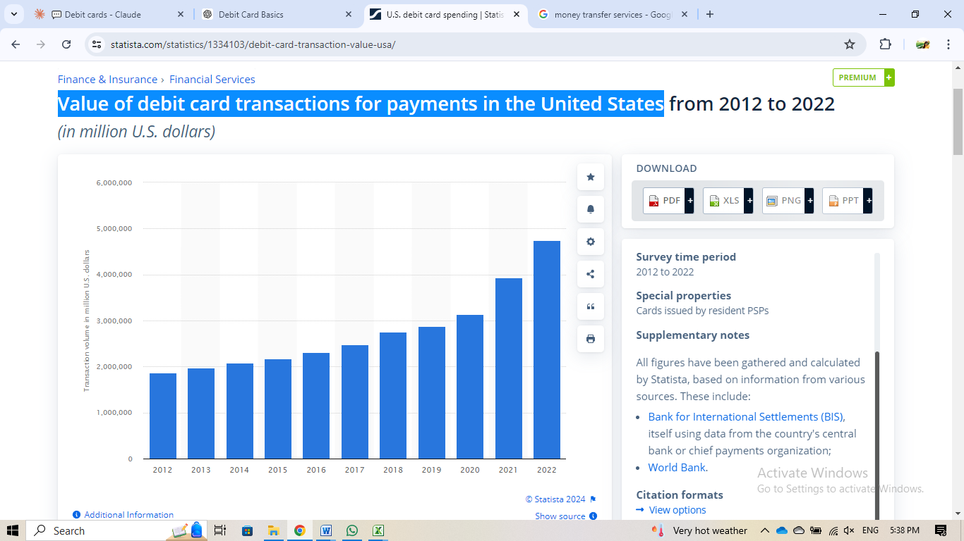**Value of debit card transactions for payments in the United States:**

Key analysis:

1. Overall Trend: There's a clear upward trend in transaction volume over the 10-year period.
2. Growth Rate: The growth appears to accelerate in later years, particularly from 2019 onwards.
3. Key Points:
   * 2012 starting point: Around 1.9 million
   * 2022 endpoint: About 4.7 million
   * Total growth: Approximately 147% increase over 10 years
4. Phases of Growth:
   * 2012-2018: Steady but relatively slow growth
   * 2019-2022: Rapid acceleration in growth
5. Notable Acceleration: The steepest increase occurs between 2020 and 2022.

Possible reasons for these trends:

1. Technological Advancements: Improved financial technologies may have facilitated easier and more frequent transactions.
2. Digital Transformation: Increased adoption of digital payment methods and online banking.
3. Economic Recovery: Post-2008 financial crisis recovery could explain the steady growth in earlier years.
4. COVID-19 Impact: The sharp increase from 2020 might be related to the pandemic, which accelerated digital payment adoption and changed consumer behaviors.
5. Market Expansion: Possible entry into new markets or launch of new financial products/services.
6. Regulatory Changes: Favorable regulations might have eased financial transactions.
7. Global Economic Factors: Overall economic growth and increased global trade could contribute to higher transaction volumes.

# Prepaid Card

Prepaid cards are versatile financial tools that can be used in a variety of contexts. Hence, it may refer to:

* Prepaid debit card: A card that debits money from an associated account that ordinarily requires use of a PIN code for verification
* Prepaid credit card: A card that debits money from an associated account that ordinarily uses a signature rather than a PIN for verification
* Stored-value card: A card that has a monetary value that is recorded as data on the card itself, and thus can be used without online access to an associated account

**Prepaid debit card:**

A prepaid debit card is much like a gift card: It allows us to spend whatever amount of money is stored on the card. We can reload the card online or at an ATM, a participating store, or another physical location when the balance is used up. Prepaid debit cards are issued by banks and they're branded by the major credit card companies, including Visa, MasterCard, Discover, and American Express.

**Features of Prepaid Debit Cards**

1. **Reloadable**: Can be loaded with funds multiple times.
2. **No Bank Account Required**: Can be used by individuals without a traditional bank account.
3. **EMV Technology**: Many have embedded chips for enhanced security.
4. **Contactless Payments**: Some support tap-and-go functionality.
5. **Usage**: Accepted at most places where debit and credit cards are used, including online.
6. **Direct Deposit**: Can receive direct deposits, including paychecks and government benefits.
7. **Spending Limits**: Limited to the amount loaded onto the card.

**Types of Prepaid Cards:**

1. General Purpose Reloadable (GPR) Cards:
   * Most common type, usable for everyday purchases.
   * Market share: 68% of prepaid card market (Mercator Advisory Group, 2024).
2. Gift Cards:
   * Pre-loaded with a specific amount, often non-reloadable.
   * Market size: $238 billion in 2023 (Research and Markets, 2024).
3. Travel Cards:
   * Multi-currency support for international travelers.
   * Usage grew by 35% in 2023 as travel rebounded (Visa Travel Insights, 2024).
4. Payroll Cards:
   * Used by employers to pay wages, especially for unbanked employees.
   * 6.5 million active payroll cards in the US as of 2023 (PYMNTS, 2024).
5. Government Benefit Cards:
   * Distribute government aid and benefits.
   * Used by 45% of US states for unemployment benefits (National Consumer Law Center, 2024).
6. Healthcare Spending Cards:
   * For healthcare-related expenses, often linked to HSAs or FSAs.
   * Market expected to reach $89 billion by 2028 (Allied Market Research, 2024).
7. Teen/Student Cards:
   * Designed for young users, often with parental controls.
   * Market grew by 28% in 2023 (J.D. Power Financial Services Study, 2024).
8. Corporate Expense Cards:
   * For business expenses and per diems.
   * Corporate prepaid card spending increased by 22% in 2023 (PYMNTS Corporate Spending Report, 2024).

**Advantages of Prepaid Cards**

1. **Safer than Cash**: Less risk if lost or stolen compared to carrying cash.
2. **Control Over Spending**: Can only spend the amount loaded onto the card.
3. **Accessibility**: Available to individuals without traditional bank accounts.
4. **Direct Deposit**: Can receive payroll and benefits directly.
5. **Budgeting**: Useful for managing budgets and limiting spending.
6. **Worldwide Acceptance**: Accepted at most places where debit and credit cards are accepted.
7. **No Credit Check**: Generally do not require a credit check for issuance.
8. **Security**: Enhanced security features like EMV chips and contactless technology.

**Disadvantages and Risks**

1. **Fees**: Can have various fees, including purchase fees, reload fees, ATM withdrawal fees, and inactivity fees.
2. **Limited Protection**: Less consumer protection compared to credit cards.
3. **Access Issues**: Technical problems or network outages can restrict access to funds.
4. **Potential Loss**: If lost or stolen and not registered, funds may be irrecoverable.
5. **Limited Rewards**: Generally offer fewer rewards compared to credit cards.
6. **Acceptance Issues**: Some merchants and services may not accept prepaid cards.
7. **Website Security**: Risk if the card provider's website is insecure.

**Government Use of Prepaid Cards**

* **Municipal ID Cards**: Cities like Oakland and Chicago offer prepaid debit cards as part of municipal ID programs, often targeted at unbanked populations, including undocumented immigrants.
* **Benefit Payments**: The U.S. federal government and other governments use prepaid cards to distribute benefits such as social security, unemployment benefits, and tax refunds.
* **Advantages**: Cost savings, increased security, and easier access to funds for recipients.
* **Challenges**: Higher fees compared to traditional banking services, potential for misuse.

**Market Data:**

1. Market Size: The global prepaid card market was valued at $2.09 trillion in 2023 and is projected to reach $4.10 trillion by the end of 2030, with a projected CAGR of 10.09% from 2024 to 2030.
2. Transaction Volume: In 2023, prepaid card transactions globally reached 54 billion, a 12% increase from 2022.
3. Regional Adoption: North America remains the largest market, accounting for 40% of global prepaid card transactions in 2023.
4. User Demographics:
   * 35% of prepaid card users are millennials
   * 28% are Gen Z
   * 22% are Gen X
   * 15% are Baby Boomers
5. Average Load Amount: $192 per load in the US, up 8% from 2022.

**Recent Trends**

1. Digital Prepaid Cards: As of Q1 2024, digital prepaid cards (virtual cards) accounted for 35% of all new prepaid card issuances, up from 22% in 2022.
2. Corporate Use: Business use of prepaid cards for employee expenses and disbursements increased by 28% in 2023 compared to the previous year.
3. Remittances: Prepaid cards used for international remittances saw a 19% growth in transaction volume in 2023.
4. Government Programs: Government-issued prepaid cards for benefits distribution increased by 15% globally in 2023, driven by digitalization efforts.
5. Cryptocurrency Integration: As of 2024, 10% of prepaid card providers offer cards that can be loaded with cryptocurrencies, up from 3% in 2022.

**Emerging Use Cases;**

1. Travel Cards: Multi-currency prepaid travel cards saw a 40% increase in adoption in 2023 as international travel rebounded.
2. Teen Banking: Prepaid cards marketed for teenagers grew by 25% in 2023, as parents seek controlled spending solutions for their children.
3. Gig Economy: Use of prepaid cards for gig worker payments increased by 32% in 2023.

**Challenges and Concerns:**

1. Fee Transparency: In 2023, regulators in several countries introduced stricter fee disclosure requirements for prepaid cards.
2. Fraud Protection: Prepaid card fraud increased by 9% in 2023, prompting issuers to implement advanced security measures.
3. Financial Inclusion: While prepaid cards have improved financial access, 15% of users still report difficulties in transitioning to traditional banking products.

**Future Outlook:**

1. Personalization: By 2026, it's projected that 70% of prepaid card programs will offer personalized rewards and cashback options.
2. Biometric Security: Adoption of biometric authentication for prepaid cards is expected to reach 40% by 2027, up from 12% in 2023.
3. Open Banking Integration: By 2025, 50% of prepaid card issuers are expected to integrate with open banking platforms, enabling more seamless fund transfers and account mnagement.
4. Sustainable Materials: The use of eco-friendly materials in physical prepaid cards is projected to reach 60% of new issuances by 2028.

Thank You